**Set-1**

**Feature 1: Reporting & Analytics Dashboard**

Build a dashboard that summarizes and visualizes application data. Describe your data aggregation and visualization choices(e.g., To monitor user activity, feature usage, and system performance)

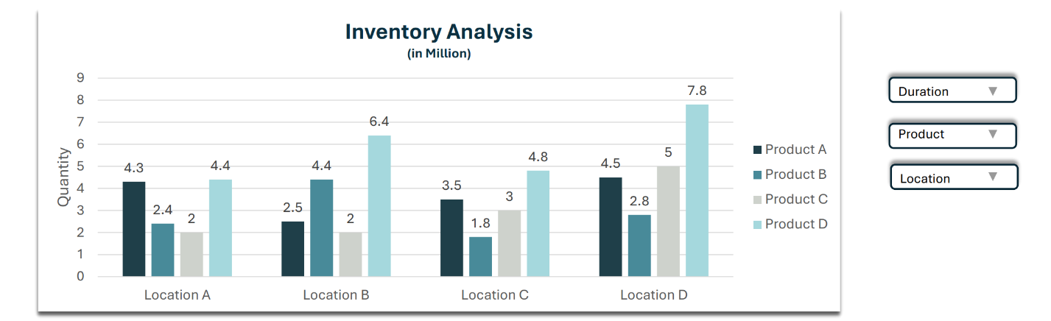

**What to Show on the Dashboard:**

* **Duration** – A dropdown to select the time period (e.g., monthly, quarterly, yearly, or a specific date range).
* **Product** – A dropdown to filter by product type (Product A, B, C, or D).
* **Location** – A dropdown to filter inventory data by geographic location (Location A, B, C, or D).

**Score 0:** No implementation

**Score 1:** Static or placeholder charts

**Score 2:** Charts display basic hardcoded or manually entered data

**Score 3:** Dynamic charts using backend data with basic filtering

**Score 4:** Interactive charts with filtering, date range, export with backend and frontend integration

**Score 5:** Advanced dashboard with real-time metrics, and user-specific insights with backend and frontend integration

**Feature 2: Product Catalogue**

Implement advanced filtering and sorting for a list of items (e.g., user list, product catalogue, etc.)- Real estate Portal

**A user must create update any of the values and delete one of the listing**

* Apartments in India
* Rent between Rs.15000 – 25000
* At least 1,2,3 bedrooms
* Sorted by "Newest First"

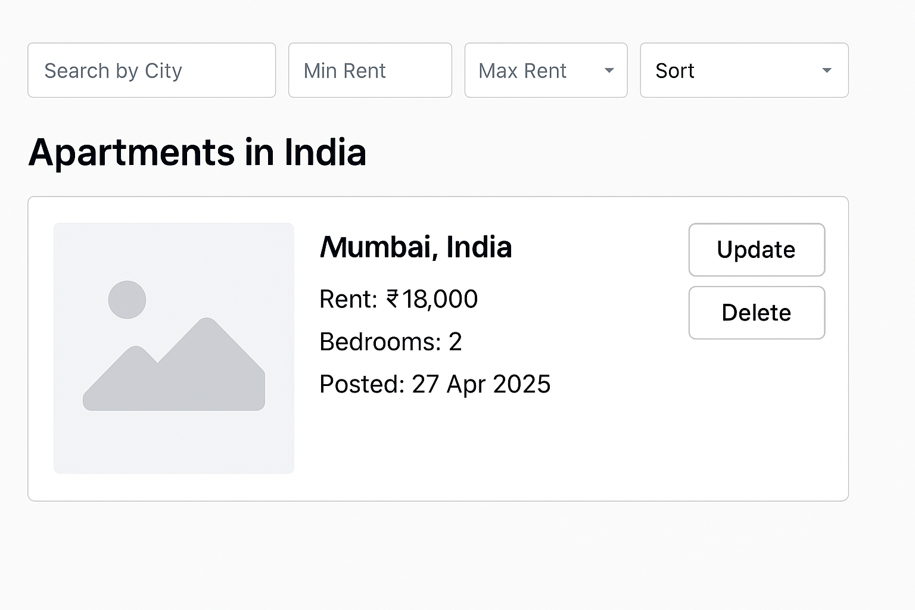

**Score 0:** CRUD is not completed

**Score 1:** No filtering or sorting functionality

**Score 2:** Basic sorting by a single field (e.g., alphabetical, numerical)

**Score 3:** Multiple sorting and filtering options (e.g., sort by price, filter by category) with backend and frontend integration

**Score 4:** Infinite scrolling (load more items as user scrolls down smoothly).

**Score 5:** Real-time updates (automatic refresh of listings), multi-level sorting (e.g., by date and price together) with backend and frontend integration